A

PROJECT

REPORT

ON

**“COVID 19 INDIA”**

FOR THE COURSE

DATA SCIENCE

SUBMITTED BY:

VAIBHAV SINGH

SUBMITTED TO:

BOARD INFINITY

2021

INTORDUCTION

* The highly infectious coronavirus disease (COVID-19) was first detected in Wuhan, China in December 2019 and subsequently spread to 212 countries and territories around the world, infecting millions of people.
* In India, a large country of about 1.3 billion people, the disease was first detected on January 30, 2020, in a student returning from Wuhan. The total number of confirmed infections in India as of August 11, 2021, is more than 6 Million and is currently very slow.
* The current COVID-19 pandemic has fundamentally shifted the way people live and work. Planning how to mitigate the effects of the pandemic is therefore crucial in order to protect workers, provide reassurance to other interested parties and to protect the organization's reputation
* We hope that such state wise analysis would help the state governments better channelize their limited health care resources and to work on betterment Of health infrastructure to restrict the harmness of this type of decease.

**TOOL USED:**

TABLEAU PUBLIC

DASHBOARD SCREENSHOT:

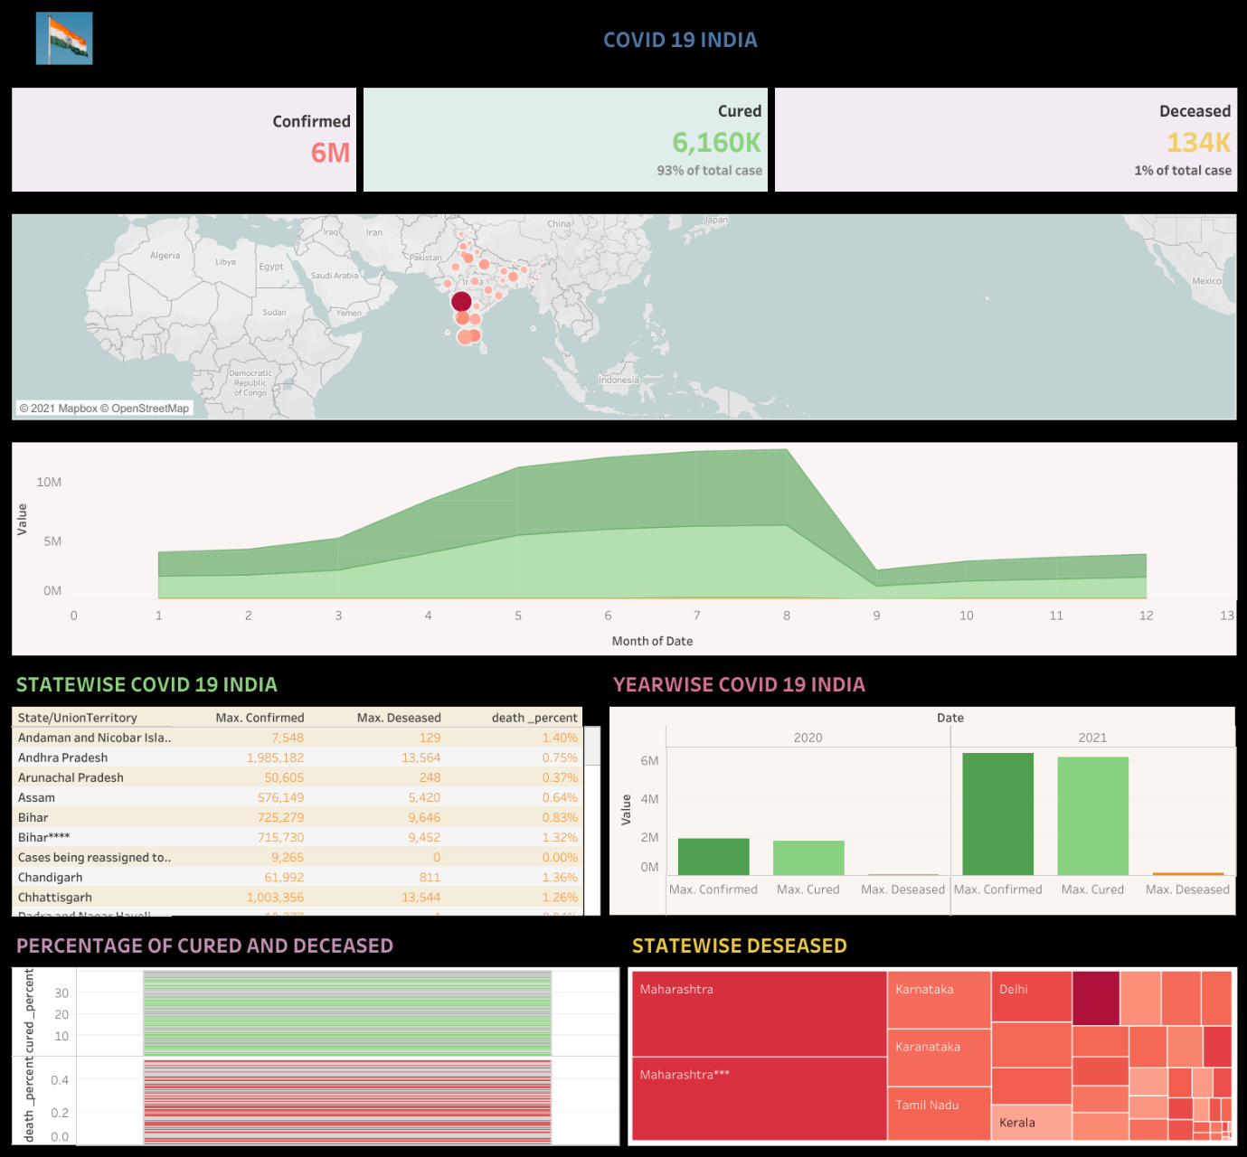

CONCLUSION

* It was a good learning experience for me while working on this project. It helps me to understand knowledge and gave real insights in the world about COVID 19 INDIA.
* Through this project I would like to help community to aware conscious precaution taken by the government and people of India also in various parts of the country, cities for battle of this type of decease in future. The trend what I have seen after analyzing data and graphs is given below-
* The number of people who have tested positive for Covid-19 in India has crossed 60 lakh.
* On September 17, India saw its highest single-day spike with 97,894 new cases being reported.
* Thirty-five of the country's 36 states and Union Territories have reported Covid-19 cases so far.
* Maharashtra has maximum number of cases and death percentage is also high.
* Only Lakshadweep has not reported any case so far..